

2025
Submitted to: DEPI
Made by : Microsoft Power BI Specialist
Reverse Logistics Return
From Supply Chain
In E-commerce world
Graduation Project

Power BI Project Documentation

Reverse Logistics Return

By group :CLS GIZ3_DAT2_S3

Project Team :
1-Hasnaa Hassan Dahab
2-Nourhan Mohamed Ragab
3-Aalaa Aboelazm
4-Abdelrahman Mohamed Soliman

Information about project
What is reverse logistics return ?
It is the management of everything that comes back to your store—whether it’s a customer returning a defective phone, an old laptop traded in for a discount, or unsellable inventory being sent back to a supplier.
In what can it be used?
- Customer Returns: Handling products returned due to damage, defects, or "change of mind."
- Repairs & Warranties: Moving devices from the customer to a service center and back.
- Refurbishment: Taking used or slightly damaged electronics, fixing them, and reselling them as "Refurbished" at a lower price.
- End-of-Life Recycling: Proper disposal of e-waste (batteries, old circuit boards) to comply with environmental laws.
Why did we analyze this problem?
- Financial Impact: Returns are expensive. In the U.S. alone, returns represent approximately 16.5% of total online sales. For electronics, where value depreciates quickly, holding returned stock is a massive financial leak.
- Rising E-Waste: Electronic waste is one of the fastest-growing waste streams in the world, rising by about 5% annually. Analyzing this helps stores find sustainable ways to dispose of old tech rather than filling landfills.
How the reverse logistics process ?
- Gatekeeping (Authorization): The customer requests a return. The store verifies if the device is eligible.
- Collection: The device is physically brought back to the store or shipped via a courier.
- Inspection & Sorting (The Critical Step): Technicians test the device to decide its fate.
- Is it unopened? →Return to shelf as new.
- Is it damaged? →Send to Refurbishing.
- Is it broken? →Harvest parts (screens, chips) for repairs.
- Is it obsolete? →Send to Recycling.
- Disposition: The action is taken (Repairing the laptop, repackaging the phone, or recycling the battery).
- Redistribution: The product re-enters the market (sold as "Used/Refurbished") or raw materials are sold to recyclers.
Describe the data
Data Source: Internet research + helps AI tools
In first columns normalized to tables by Nourhan
- Fact Table :
- Returns_facts→ Central fact table containing 20K return transactions with metrics for refunds, costs, quantities, handling times, and supplier lead times
- Dimension Tables :
- Branch_dim - Store locations, cities, countries, sales channels (online/instore)
- Customer_dim - Customer profiles and segmentation data (19K customers)
- Date_dim - Time dimension with return dates, purchase dates, year, month, quarter
- Disposition_dim - Return disposition types, conditions, restockable/repairable/refurbishable flags
- Product_dim - Product catalog with categories (Cameras, Smartphones, Kitchen Appliances, Wearables, Laptops, TV & Audio), pricing, costs
- ProductStatus_dim - Product status tracking and classifications
- ReturnDetails_dim - Detailed return information and attributes
Next step Data Transformations (by using Power Query) by Nourhan
- Data Quality: Removed duplicates from return_id column ensuring data integrity
- Boolean Conversion: Transformed restockable, repairable, refurbishable fields from Boolean to Text (True→Yes, False→No) for better reporting
- Warranty Logic: Implemented business rules for null warranty expiry dates: Out of Warranty status → added 3 months to return_date
- Extended Warranty status → added 3 months to return_date
- Date Validation: Created calculated column to handle negative days_to_return values, setting invalid dates to BLANK()
Relationships:
Disposition_dim
Branch_dim
Customer_dim
Returns_facts
Date_dim
ProductStatus_dim
Product_dim
ReturnDetails _dim

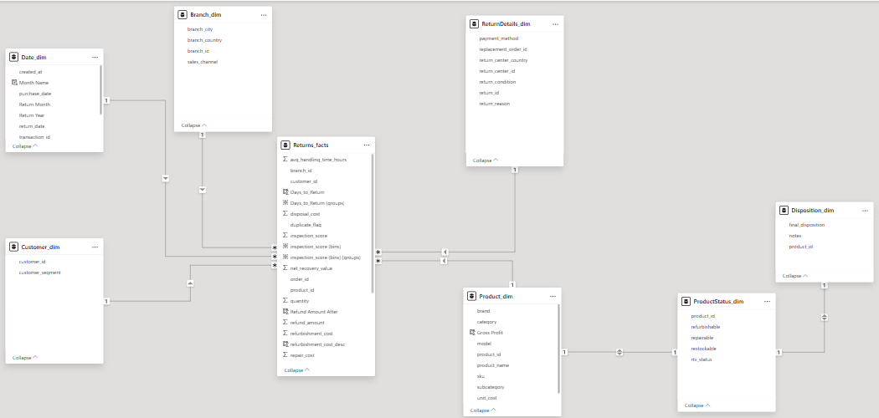 Next step come Dax for measurers & calculated columns by Hasnaa
- Returns & logistics:
- Total Returns = COUNTROWS(Returns_facts)
- Total Logistics Cost = SUM(Returns_facts[disposal_cost])+SUM(Returns_facts[repair_cost])+Sum(Returns_facts[refurbishment_cost])+Sum(Returns_facts[return_shipping_cost])+SUM(Returns_facts[reverse_logistics_cost])
- Total_Cost_Per_Return = Returns_facts[reverse_logistics_cost] +Returns_facts[refund_amount]→ in Returns_facts
- Cost Per Return = DIVIDE([Total Logistics Cost], [Total Returns], 0)
- Total Quantity = SUM(Returns_facts[quantity])
- Total Refund Amount = SUM(Returns_facts[refund_amount])
- Total Fees Paid =SUM(Returns_facts[disposal_cost])+ SUM(Returns_facts[repair_cost])+
Sum(Returns_facts[refurbishment_cost])+ Sum(Returns_facts[return_shipping_cost])+ SUM(Returns_facts[reverse_logistics_cost])
- Total Fees Paid After =
SUM(Returns_facts[disposal_cost])+
SUM(Returns_facts[Repair_cost_Desc])+
Sum(Returns_facts[refurbishment_cost_desc])+
Sum(Returns_facts[return_shipping_cost])+
SUM(Returns_facts[reverse_logistics_cost])
- Total Money Paid On Returns = [Total Fees Paid] +[Total Refund]
- Total Shipping Cost = Sum(Returns_facts[return_shipping_cost])

- Date :
  - Add Return Year & Month →in Date_dim
  - Avg Days to Return = AVERAGE(Returns_facts[Days_to_Return])
  - Avg Handling Time Hours = AVERAGE(Returns_facts[avg_handling_time_hours])
  - Previous Year Return = CALCULATE([Total Returns], SAMEPERIODLASTYEAR(Date_dim[return_date]))
  - QTD Return = TOTALQTD ([Total Returns],Date_dim[return_date])
  - YTD Return = TOTALYTD([Total Returns],Date_dim[return_date])
  - Supplier Lead Time Avg = AVERAGE(Returns_facts[supplier_lead_time_days])
  - Days_to_Return =
VAR PurchaseDate =
RELATED(Date_dim[purchase_date])
VAR ReturnDate =
RELATED(Date_dim[return_date])
VAR Diff = DATEDIFF(PurchaseDate, ReturnDate, DAY)
RETURN
IF(Diff <= 0, BLANK(), Diff) →in Returns_facts
  - Return_Quarter = "Q" & QUARTER(Returns_facts[return_date]) →in Returns_facts
- Branches & location :
  - All Stores= COUNTROWS(Branch_dim)
  - Online Return Rate %=CALCULATE ([Return Rate %], Branch_dim[sales_channel]=”online”)
  - Store Return Rate % =CALCULATE([Return Rate %],Branch_dim[sales_channel] = "instore")
  - Channel Gap % = [Online Return Rate %] - [Store Return Rate %]
- Customer :
  - Total Customer = COUNTROWS(Customer_dim)
- Disposition and products :
  - Disposal Count = CALCULATE( [Total Returns],Disposition_dim[final_disposition] = "Dispose" )
  - Total Disposal Cost = SUM(Returns_facts[disposal_cost])
  - % Disposal = DIVIDE([Disposal Count], [Total Returns], 0)
  - Repair & Return to Vendor Count =CALCULATE([Total Returns], Disposition_dim[final_disposition] = "Repair & Return to Vendor" )
  - Total Repair Cost = SUM(Returns_facts[repair_cost])
  - % Repair & Return to Vendor = DIVIDE([Repair & Return to Vendor Count], [Total Returns], 0)
  - Resellable Count =CALCULATE([Total Returns],Disposition_dim[final_disposition] = "Refurbish & Resell" )
  - Total_Cost_Per_Return = Returns_facts[reverse_logistics_cost] +Returns_facts[refund_amount]
  - % Resellable = DIVIDE([Resellable Count], [Total Returns], 0)
- No Replacemented order = CALCULATE(COUNTROWS(ReturnDetails_dim),ReturnDetails_dim[replacement_order_id]= "No Replacement Issued")
- Refurbished Items = CALCULATE(COUNTROWS(ProductStatus_dim),ProductStatus_dim[refurbishable] = "Yes")
- Restocked Items = CALCULATE(COUNTROWS(ProductStatus_dim),ProductStatus_dim[restockable] = "Yes")
- Repaired Items = CALCULATE(COUNTROWS(ProductStatus_dim),ProductStatus_dim[repairable] = "Yes")
- Return Rate by Category % =VAR TotalSoldCategory =
CALCULATE(
SUM(Returns_facts[quantity]),
ALL(Product_dim[category]))
VAR ReturnedCategory = SUM(Returns_facts[quantity])
RETURN
DIVIDE(ReturnedCategory, TotalSoldCategory, 0)
- Returned To Vendors =CALCULATE(COUNTROWS(ProductStatus_dim), ProductStatus_dim[rtv_status] = "Yes")

- Net & Profit :
  - Net_Impact = Returns_Facts[refund_amount] - Returns_Facts[net_recovery_value]
  - Total Net Impact = SUMX(Returns_facts, [Net_Impact])
  - Gross Profit = Product_dim[unit_price]-Product_dim[unit_cost] →in product_dim
  - Net_Impact_Per_Return = Returns_facts[salvage_value] - Returns_facts[reverse_logistics_cost] - Returns_facts[disposal_cost] - Returns_facts[repair_cost] - Returns_facts[refurbishment_cost] →in Returns_facts
  - Net Recovery = SUM(Returns_facts[salvage_value]) +SUM(Returns_facts[net_recovery_value])
  - Final_Profit = [Net Recovery] +[Initial_Profit] +[Salvage Value Earned] - [Total Fees Paid] - [Total Refund]
  - Initial_Profit = SUM(Product_dim[Gross Profit])
  - Salvage Value Earned = SUM(Returns_facts[salvage_value])

In final make Visuals and Dashboard by Aalaa and Abdelrahman
Page 1: Executive Overview
He presents more comprehensively about the topic and explains at the beginning that the initial profit was about 7M dollars, which is the value of the returned products, then the total number of return requests, the number of returned products and the average days that customers take to return the products and all our stores, whether online or online
It also displays the types of customers and the percentage of online and offline merchants
And the total costs during the months + the most returned products.
Page 2: Product & Category Performance
Here we explain more about the products and categories, and it is the first step in the return process, the products are collected and classified, and it appears here that
The total products are about 21 thousand products reviewed and classified into :
- Supplier-related products =1328
- Repaired products = 12 K
- Refurbished products =10 K
- Discarded products =2053
And in another table shows the percentage of the most returned categories and the most expensive products in repair .
And the cases of the returned products and their ratios.
Page 3: Disposition & Operations
In this board we show the operations, revenues and costs that were spent in these operations in.
As we mentioned earlier, it is assumed that the initial profit is 7 million dollars, but after the return of the products, more than 14 million dollars were spent in operations, but through these operations, about 12 million dollars were earned and some products were sold as scrap, raising the profit to more than 6 million, the final profit was about 11.21 million dollars
The other tables show the returns by geographical areas, the final product cases and the last decision regarding their disposal.
Page 4: Channel & Location Analysis
For these boards show the locations of stores around the world and more details about the returns .
And in another table that explains the total returns, their percentages, the average time taken to deal with the products, the average days that customers return the products, the percentage of products that were sold again, and all this according to each country.
Page 5: Supplier & Return Reasons Analysis
As for here, we explain in detail why customers return products, and the biggest reason was the delay in shipping, the problem was in suppliers and delivery representatives, and whether the product is out of warranty for repair or not, and analyze more broadly the product cases for the final disposition of each of them.
Page 6: Financial Impact Analysis
And in the end, we will explain how this was a profitable operation and what happened behind the scenes earlier, we explained that the costs were more than 14 million, and they included the costs of repair, renovation, logistics, the cost of disposing of the product, as well as the money returned to the customer after the product was restored, but all this made me new products and
It also shows each category its return percentage, its cost percentage, and the ratio between profit and money returned to the client.

